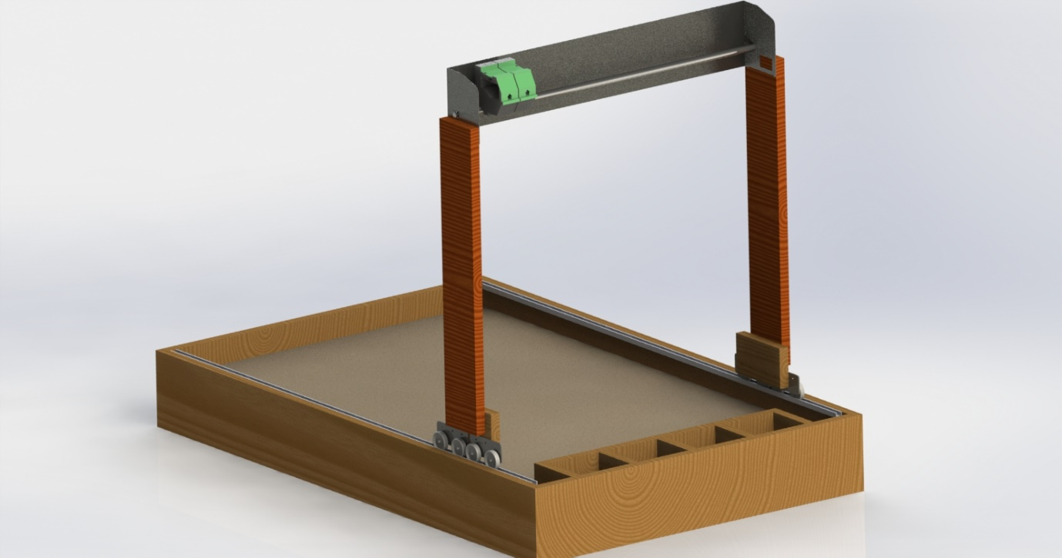

### Submitted By:

### Aarohi Kumar (14105015)

### Avi Dubey (14105048)

### Karan Thakur (14105058)

### Subham Roy (14105071)

### Haider Zulfiqar (1410505)

Project Report

FarmBot

Project Mentor:

Prof. Neelu Jain

[Year]

FARMBOT

# AIM

To make an autonomous agricultural robot to automate agricultural tasks with minimal human intervention.

# MOTIVATION

The driving factor behind the project was the need of autonomous farming robot in a developing nation like India which is on the path of agricultural and technological development. In a nation like India, agriculture is perceived as a backward or sub-normal occupation. Thus, people don’t prefer to take it up as an occupation. The problem is two-fold-

1. Due to several factors leading to hardships in this occupation, the number of farmers is on a decline.
2. Due to a skewed penetration of technology in agriculture, development in agriculture is not vast as it is in other fields like service and manufacturing.

So, the Farmbot is our humble contribution to minimise this skew in the agricultural field.

# INTRODUCTION

The Farmbot project is inspired by the Genesis v1.0 robot which achieves a similar automation in farming. But, the cost of this robot is not what an average Indian person could afford. The latest version is priced at $3900 or roughly Rs. 2,61,000. Moreover, the Genesis bot is aimed at gardening and small-scale agriculture automation, which is, in our opinion, inadequate for the food crop oriented agriculture practices of India.

Our Farmbot is designed keeping the above point in mind. The differentiating factor is the cost, at around Rs. 10,000, it is a mere 5% of what the Genesis costs.

# WORKING MECHANISM

### Movement in x-direction:

The Farmbot will have a gantry system as shown in Fig 1, which will move on the horizontal tracks, in x direction with the help of two Johnson motors. The gantry is fixed with respect to the body or chassis of the bot. The gantry consists of a printer bed which has a carriage moving in y direction only.

Figure : Structural Diagram of Farmbot

### Movement in y-direction:

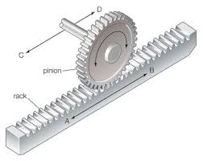The carriage is moved with the help of a DC brushed motor and the reference of position is kept using an optical encoder in the form of marked plastic tape. An IR (infrared) LED pair is used where when light from transmitter reflects across the tape and the receiver produces pulse according to the speed of movement.

Figure : Rack and Pinion Mechanism

### Movement in z-direction:

Rack and pinion mechanism is used for movement along z-direction. In this cross-slide is used. It is a type of linear actuator that converts rotational motion into linear motion. Here, circular gear is called pinion which engages teeth on linear bar called rack. Rotational motion applied to pinion causes rack to move relative to pinion thereby translating rotational motion of pinion into linear motion, directed in the z-direction.

### Mechanism for sowing seeds:

A container with seeds is attached to the boundary of the device. Different containers may be used, that can contain different types of seeds. A vacuum pump controlled by the raspberry pi is used to create suction through a nozzle. This nozzle is mounted on the rack that is mentioned in the previous para. This nozzle acts as both a picker and dropper for the seeds. The vacuum pump creates suction that will hold a few seeds to the nozzle and drop them at the required spot.

### Mechanism for irrigation:

An elevated water tank carries the water to be used for irrigation. The flow of water is controlled using a solenoid valve, which is controlled using the raspberry pi. The solenoid valve is a magnetic device having an inductive coil used as a solenoid to push and pull a plunger which acts as a valve. This device is commonly used to control the flow of fluids in hydraulic and pneumatic systems.

# POWER MANAGEMENT

All components (except the vacuum pump) of the bot are powered by a single 500W PSU. It is capable of converting 240V, 50Hz mains supply into DC, which can be further utilized by various electronic components. The particular PSU we are using is capable of producing maximum output power of 500W and DC voltage in range 3.3V-12V. The current rating for the PSU is as follows:

|  |  |
| --- | --- |
| **Voltage** | **Maximum Current Output** |
| 3.3V | 7 A |
| 5V | 15 A |
| 12V | 10 A |

# CIRCUIT DIAGRAM

The circuit diagram is as follows:

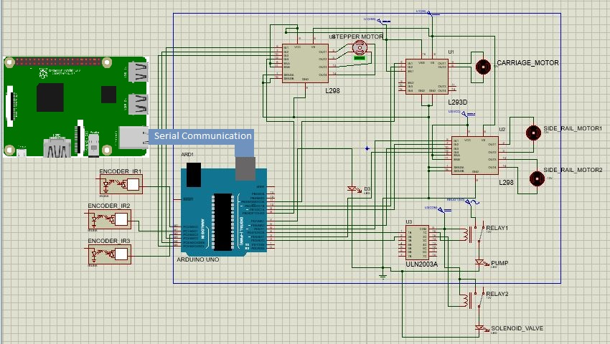

Figure : Circuit Diagram of Farmbot

Further explanation of each component is explained further.

## Arduino Uno

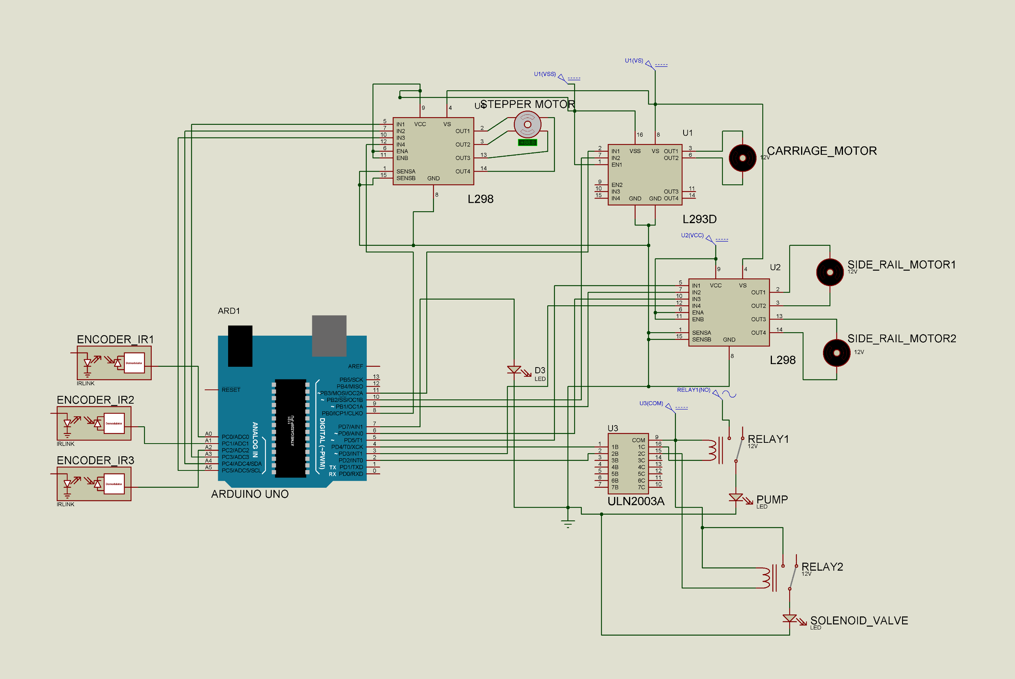Arduino Uno is a development board and a framework based on the extremely popular MCU by Atmel known as the ATMEGA 328P. This MCU has a 32kB of flash memory for instructions and data and a 2kB of on-board RAM. The major advantage of using the Arduino Uno platform is the highly-developed framework for performing each and every function using the C language instead of assembly language code. C language supports a high amount of abstraction, so the user does not need to know non-relevant information while programming.

Figure : Schematic for Arduino Uno

The pin-usage for the Arduino Uno in the project is as follows:

|  |  |  |
| --- | --- | --- |
| **Purpose** | **No. of GPIO pins used** | **Type of pin** |
| Z-axis Stepper Motor | 4 | Digital Output |
| Left Johnson Motor | 2 | Digital Output (PWM) |
| Right Johnson Motor | 2 | Digital Output (PWM) |
| Carriage Motor | 2 | Digital Output (PWM) |
| Left Optical Encoder | 1 | Analog Input |
| Right Optical Encoder | 1 | Analog Input |
| Carriage Encoder | 1 | Analog Input |
| Solenoid Valve Relay | 1 | Digital Output |
| Air Pump Relay | 1 | Digital Output |
| Lights (Placed on the gantry) | 1 | Digital Output |

## Optical Encoders

An optical encoder is an optical device that provides a feedback signal based on the location (absolute or relative) of a particular component. Optical Encoders may be of many types like:

Figure : Schematic for Optical Encoder

1. Linear Encoders
2. Circular Encoders
3. IR type
4. Visible light type

The optical encoders used in the project are composed of IR LED pairs. This is why, the schematic is represented by an optocoupler. The encoder is connected to a body which is supposed to move. Each pair, along with the body, is run along a tape with alternate white and black markings. The photodiode in the pair will detect the colour difference in the markings and generate a pulse train when the encoder moves along the tape.

The position is decoded by the MCU by keeping track of number of negative edges received in the pulse train. Thus, if the encoder generates 5 negative edges, and the tape has a distance of 1 cm between each marking, then the total distance covered is 10 cm.

1 cm

Figure : Illustration of the Optical Encoder Tape

The advantages of using optical encoder based motion, over open-loop motion is,

1. Better Accuracy of motion:

In this system, we are tracking the current position using the optical encoder, so there is precise control over where to stop the motion and so on.

1. Usage of various control algorithms like PID control:

The motion generated by an MCU is rather sharp and rigid. So, the motion may start and stop very rapidly. This causes wear of various mechanical parts and unwanted vibrations. This can also lead to over and under movement. Thus, various algorithms like PID and Fuzzy control may be implemented for smoother motion. PID control is explained further.

## Motor Drivers (L298 and L293D)

The MCU cannot provide the required current to drive a motor or other mechanical systems. This is why motor driver IC are used. These provide a way to isolate the high current providing circuit with the MCU. Many motor drivers also have build-in flyback diodes and discharging capacitors to protect the MCU from back EMF from the inductive loads.

Figure : Schematic for L298 Motor Driver

Two types of motor driver ICs are used in the project, L298 and L293D. Both these ICs are manufactured by ST Microelectronics. The main difference between the two drivers is of output current range. The l298 has two channels for controlling two motors at a time with a maximum current ouput of 2A for each channel. While the L293D comes in a DIP package, thus having a low current output of 1A per channel with a total of two channels. Also, L298 does not have build-in flyback diodes while l293D does.

These motor drivers also have support for motor speed control using PWM (Pulse Width Modulation). In this tehnique, the MCU generates a pulse of a certain duty cycle as an input to the motor driver, which in turn converts this to a pulse of higher voltage, with the same duty cycle. This high voltage pulse is applied to the motor. Thus, the motor winding switches on and off rapidly and the motor rotates at an angular speed proportional to the duty cycle applied.

## Relays

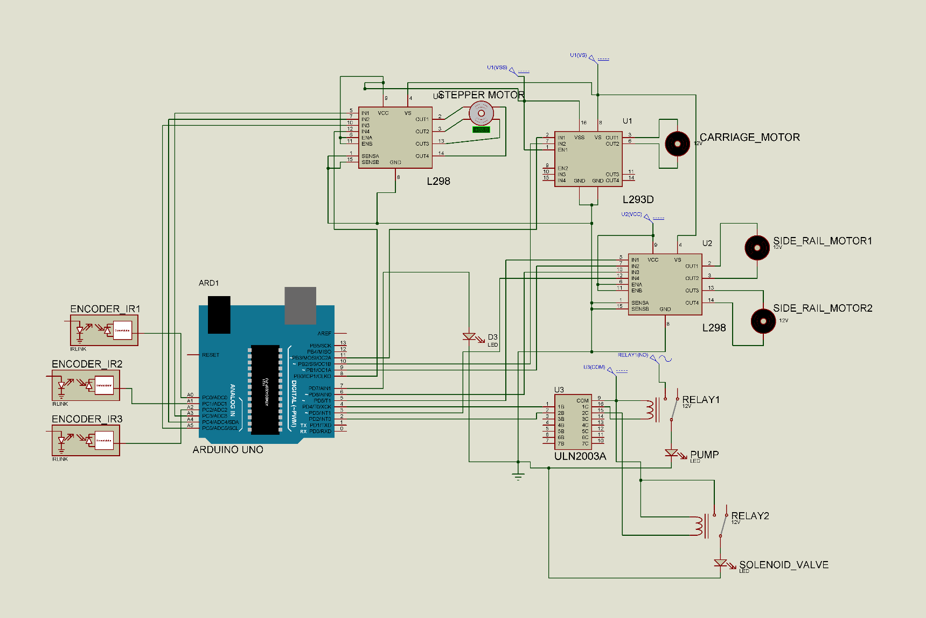A relay is an electro-mechanical device which is used as a switch to control a large voltage supply using a small voltage.

Figure : Schematic for Relay and ULN2003A

A relay is composed of an electromagnet and a DPDT switch. As the electromagnet coil is turned on by a small voltage source, it attracts the switch lever towards it, thus completing the circuit for the large voltage supply.

A relay’s input coil is composed of an inductive load, so it too cannot be driven directly by an MCU. To drive the input circuit of a relay, we use an IC called ULN2003A. It is an array of 7 BJT Darlington pairs.

## Carriage Motor

The carriage motor is a part of the movement assembly which moves the carriage containing the z-axis mechanism left or right (along the y axis). The carriage motor is a DC brushed motor. The carriage is driven using a belt drive. The belt runs along the y-axis through the motor spool and a pulley. The carriage motor is controlled by Arduino using the feedback data from the optical encoders. The carriage motor is driven using the L293D motor driver.

## Johnson Motors

The Johnson motors are high torque motors with a reduction gear system to decrease the rpm thus increasing the torque. Two Johnson motors are used to drive the gantry along the x-axis. These are controlled using the high current motor driver ICs i.e. L298. The Johnson motors provide a torque of 30 Ncm.

# CONTROL MECHANISM

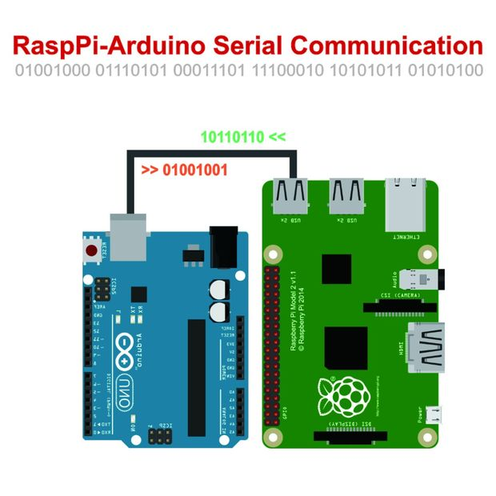The Farmbot is powered by a Raspberry Pi 3 and an Arduino Uno. The Raspberry Pi 3 is a single board computer run by a 1.2GHz 64-bit quad-core ARMv8 CPU. The operating system used is Raspbian, a free OS based on Debian optimized for the Raspberry Pi hardware. Raspbian comes preloaded with Python, the official programming language of the Raspberry Pi and IDLE 3, a Python Integrated Development Environment. Python is used to interface the raspberry pi with external devices. The Arduino Uno on the other hand is a single board microcontroller that uses an ATmega328 microcontroller. The device is programmed using C programming language.

The Raspberry Pi performs the following functions:

Figure : Serial Communication between Raspberry Pi and Arduino

1. The various operations performed by the Farmbot are all controlled by the Raspberry Pi. The control signals are then sent to the Arduino Uno serially which are then mapped with functions in C programming to control the hardware devices used in the Farmbot.
2. A camera is mounted on the gantry for observing the plant growth and to detect the presence of weeds. This is done with the help of computer vision and image processing. The camera is connected to the Raspberry Pi, which allows us to use OpenCV in python to perform the various computer vision algorithms.
3. With an internet connection, the system can automatically syndicate weather forecast information using several online APIs, and accordingly decide the amount of water to use for irrigation. For example, if rains are expected in near future, the system can use lesser amount of water.
4. The Raspberry Pi is also able to host a web server service. This can be exploited to use the Farmbot from remote location. A control interface using Internet Protocol can be devised that will make it possible to control it manually.

### Control Architecture:

**Feedback Mechanism**

Optical Encoders along the drive.

Figure : Block Diagram of the Control System for motion

The figure 3 above, shows the flow of control through various components in the system.

The Arduino here, is acting as a priority queue for performing the operations, as the system can do only one work at a time. The Raspberry pi acts as a feed for control commands, which the Arduino interprets and stores in a queue arranged in the order of their priority. The commands are purged once they are executed.

The Arduino is also responsible for controlling the motors and actuators. This is done using the principles of Numeric Control, widely used in applications like printers and CNC machines. A feedback mechanism composed of optical encoders is used to keep track of the movement of the gantry and the cross slide/carriage. The optical encoders employ an IR LED pair which are made to pass over a marked tape, with alternate black and white (clear) markings. The movement generates a pulse output across the photodetector, from which the relative displacement can be calculated by counting the number of negative edges starting from a certain time instant.

# TECHNICAL SPECIFICATIONS

## Hardware Components:

1. Raspberry pi Model 3 B+
2. Arduino Uno
3. L298 Motor Driving IC
4. Johnson High torque motor
5. Camera

## Other Components:

1. Vacuum pump
2. Rack and pinion mechanism
3. Cross slide and gantry mechanism

# SCHEMATICS AND IMAGES

|  |  |
| --- | --- |
| https://upload.wikimedia.org/wikipedia/commons/b/b4/Raspberry_Pi_3_Model_B.png  Raspberry Pi Single Board Computer | https://cdn.shopify.com/s/files/1/0775/1525/products/A000066_featured_1024x1024.jpg?v=1460564034  Arduino Uno |
| Johnson Motor used for locomotion | Electric Air Pump |
| Switched Mode Power Supply Unit | C:\Users\roy\AppData\Local\Microsoft\Windows\Temporary Internet FilesContent.Word\IMG_20161025_201636.jpg  Printer Bed Mechanism |

# REFERNCES

1. Most of the design is based on the Genesis Farmbot v1.0 White Paper at <https://drive.google.com/file/d/0B-wExYzQcnp3ZWxheXgwRU1yVkU/view>
2. Weed Recognition Using Image-Processing Technique Based on Leaf Parameters at <http://www.davidpublishing.com/davidpublishing/Upfile/9/23/2012/2012092383363257.pdf>